Operating Manual
For
Runner Tracker

Abstract:
Runner Tracker is a program used for Ultra Run and similar activities to collect and transfer runner data from Aid stations along the route to a Central Database to facilitate tracking the runners’ progress and well-being.

Table of Contents
No table of contents entries found.

System Requirements
Runner Tracker, having been written in the C# programming language, requires that the .Net Framework be installed on the PC. Windows 8 and 10 come with this component included, so they should be natively usable. Any PC running Windows 7 or before will need to have the .Net Framework installed. It can be downloaded from the Microsoft download site. Windows XP will need to have 4.0.30319 installed. Windows 7 can use the same version or can go to version 4.5 or 4.6.

Installation Instructions

User choices saved in the PC registry.

Starting the program – Choose a Role
When the Runner Tracker starts, it presents the user with this screen:
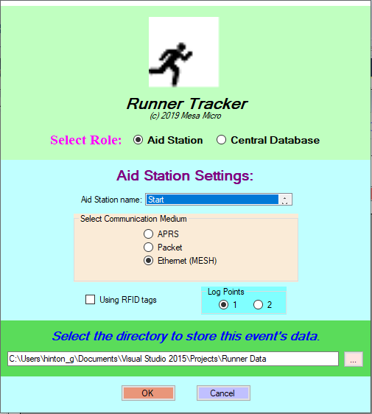

The user must use the radio buttons after the label Select Role to choose whether he will be using the program at an Aid Station or at the Central Database. Since the Aid Station radio button is highlighted, the bottom half of this screen shows the initial settings possible for an Aid Station activation. Go now to section 4.0 or 5.0 to see how to start the Aid Station or Central Database roles.
If the user starts the program, closes it and starts it again, within a minute, this message will appear:
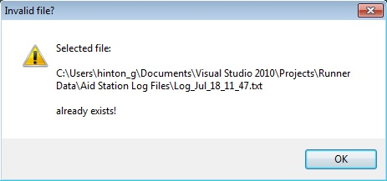
Click the OK button and the original log file will be overwritten by the one for the latest starting of the program.

After the role is selected, if the Communication Medium chosen includes Ethernet (MESH), and if more than one Ethernet port is available and active, the user must choose which one to use. A window similar to this one will appear:
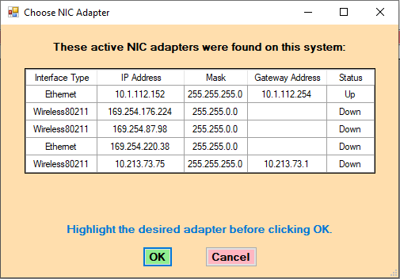

Aid Station role activation
When the Runner Tracker starts up, it presents the user with this screen:
Before clicking the OK button, to start the Aid Station activation, verify these things:
- Station name – if the Stations text file is accessible, then the available names will be shown in the list box by using the arrows at the right. If the Stations file is not accessible, the name shown will be: “Not yet identified”.
- Choose which Communication Medium will be used: APRS, Packet, or Ethernet (MESH).
- Will RFID tags will be used for the runners?
- Will there be two Log Points? One at the entrance to the Aid Station and one at the exit?
- A directory (folder) must be selected to store the activities of this event. Use the button to the right to browse to the location and create a new folder if needed.
The Cancel button can be clicked if you decide not to start the program.

The initial, Select Role screen will disappear once the user selects to be an Aid Station. The Aid Station main window will now appear. The first activity of the Aid Station is to get connected to the Central Database. The status messages at the top of the screen shows the status of this connection, as seen here: Also notice the Settings tab is highlighted in RED.
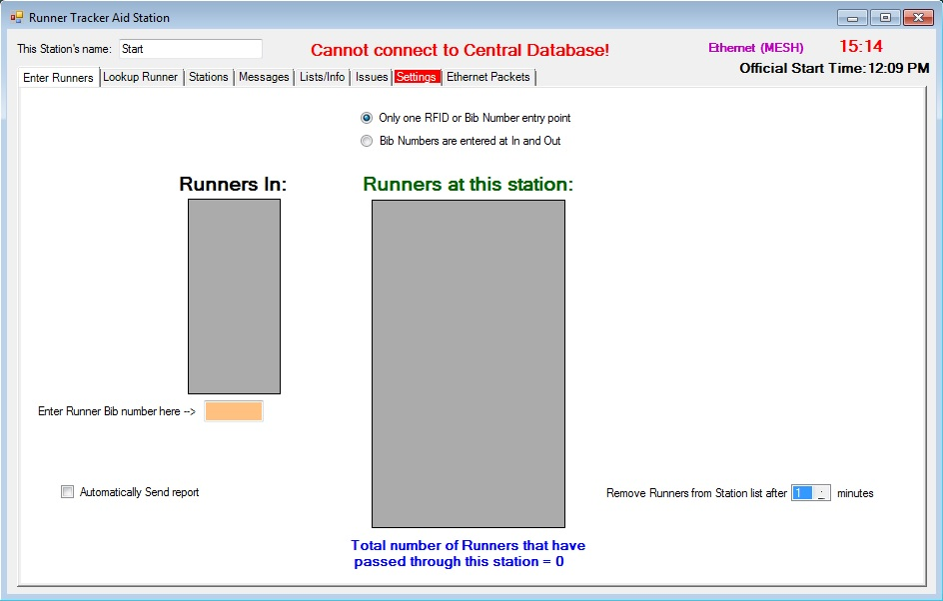
Status messages that can appear include:
Initting connection
Attempting connection to Central Database
Connected to AGWPE
Connected to Central Database
Connected to Central Database & Active – this is the final connected state
Some error status messages include:
Lost Connection
Cannot connect to Central Database!
Error connecting to Central Database!
The Aid Station screen shown above does not allow connection to the Central Database because of a missing setting. Go to the Settings tab to see what needs to be changed.
On the Settings tab, notice that the Central Database IP address is missing. Enter the proper IP address and the Aid Station should start the connection process.
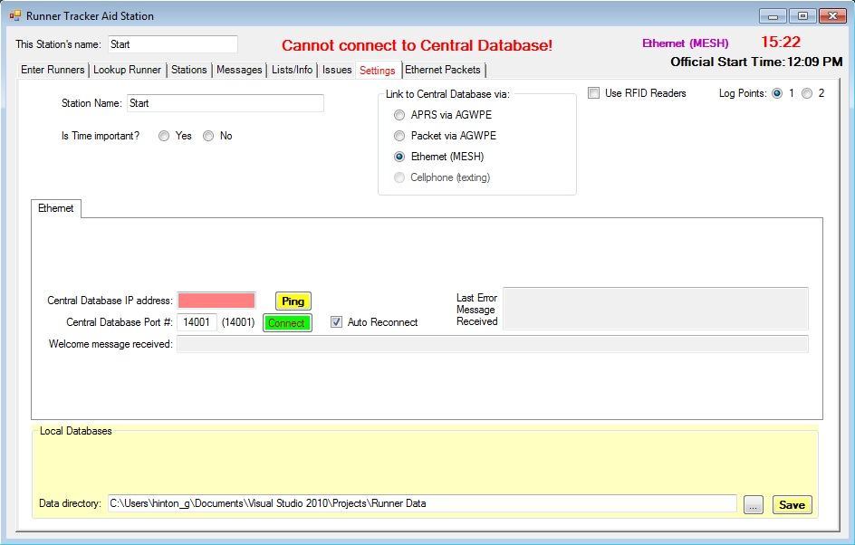
Once the Aid Station has started connecting to the Central Database, do not attempt to make any changes until the final state of Connected & Active is achieved. Certain things are not available until connection is made with the Central Database, one of which is shown in the next screen. Since this Aid Station is not connected to the Central Database, it cannot send messages to or receive messages from the Central Database.
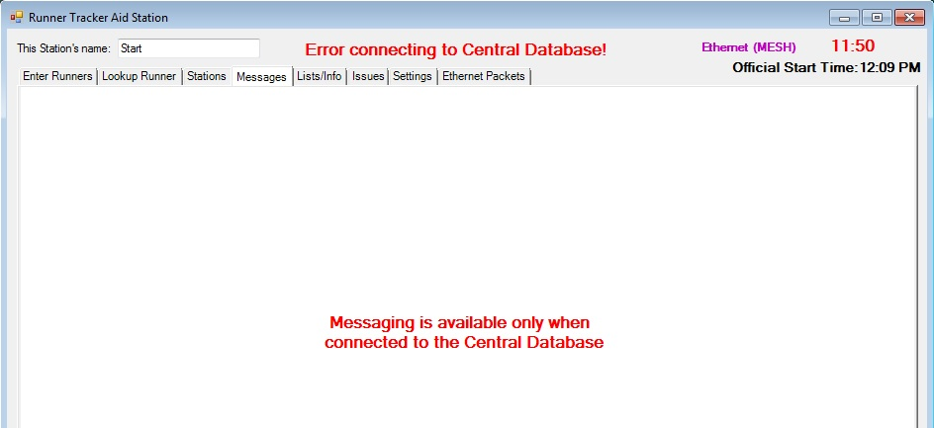
Also, the Connected & Active state will not be met, until all the lists are requested and received from the Central Database. Click the Lists/Info tab to watch as these lists are downloaded.
There are 4 lists and the Info file that will be downloaded. As each one is downloaded, one of these two popup windows will appear, indicating that either the list was received or that it is not available:
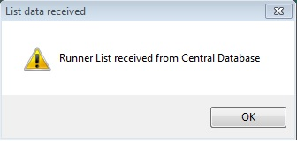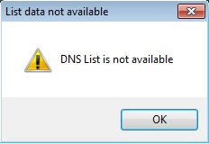
After the four lists and the Info file have been downloaded from the Central Database, then the Aid Station can begin full activity. Checkout all the tabs in the main menu:
Enter Runners
Lookup Runner
Stations
Messages
Lists/Info
Issues
Settings
Ethernet Packets – this tab will change to “APRS Packets” or “Packet Packets” if one of those communication mediums is being used.
The Enter Runners tab will be different, depending on how many Log Points are being used at the Aid Station, as shown here:
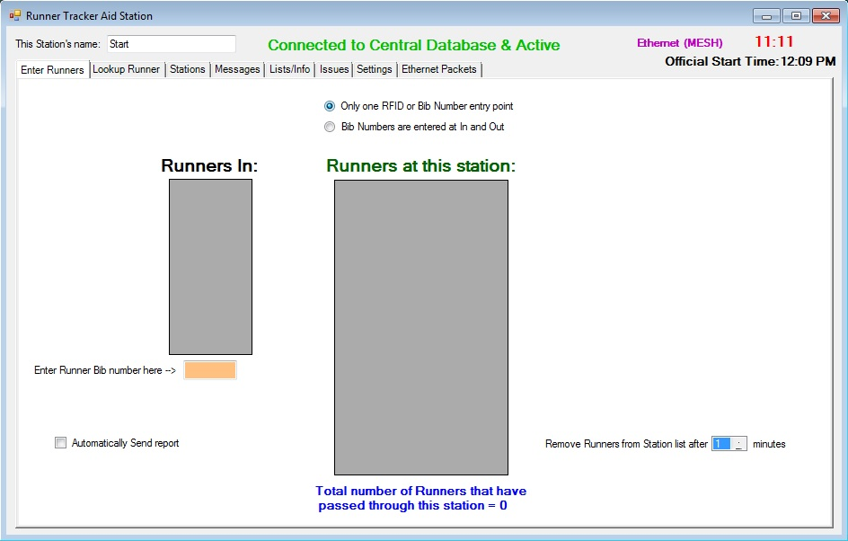
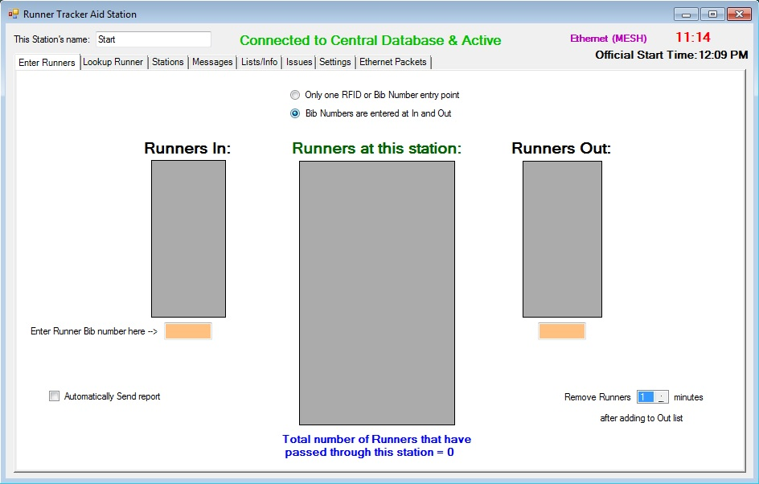
Other popup windows that can appear:
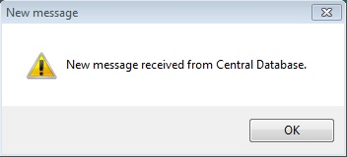

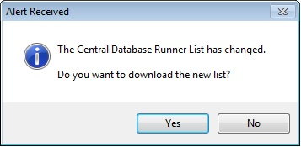
Runners List changed at DB, download
Could happen for any of the lists

Message tab:
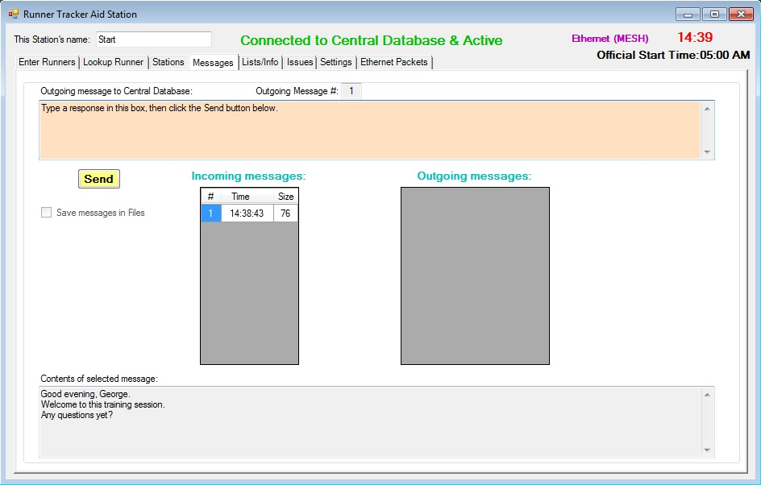

Central Database role activation
When the user selects the Central Database role, the initial screens changes to this:

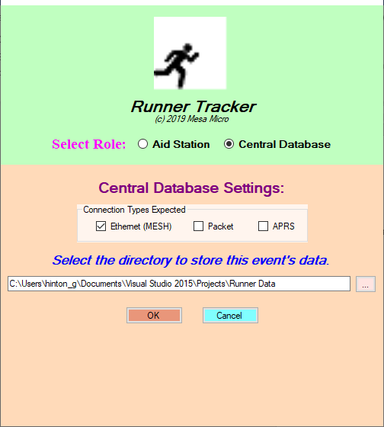

Before clicking the OK button, verify these things:
- What Connection Types are to be expected? Ethernet (MESH), Packet or APRS?
- A directory (folder) must be selected to store the activities of this event. Use the button to the right to browse to the location and create a new folder if needed.

The Cancel button can be clicked if you decide not to start the program.
If a Runner data file already exists in the directory selected, the following question needs to be answered before starting:
